**package** exp1;  
  
**import** java.applet.Applet;  
**import** java.awt.*;  
  
*//<applet code = Exp1_1 height = 400 width = 400> //</applet>***public class** Exp1_1 **extends** Applet {  
  
 **public void** init() {  
  
 Checkbox cb = **new** Checkbox(**"Apple"**);  
 add(cb);  
 Checkbox cb2 = **new** Checkbox(**"Microsoft"**,**true**);  
 add(cb2);  
  
 CheckboxGroup cbg = **new** CheckboxGroup();  
  
 Checkbox rb = **new** Checkbox(**"Desktop"**,cbg,**true**);  
 add(rb);  
 Checkbox rb2 = **new** Checkbox(**"Laptop"**,cbg,**false**);  
 add(rb2);  
  
 }  
}

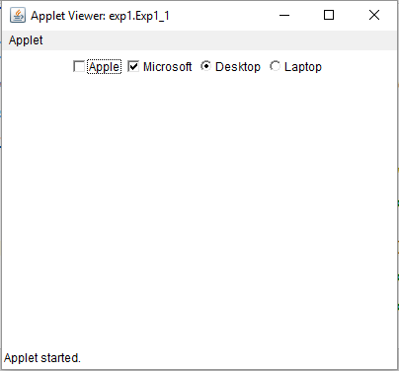

**package** exp1;  
  
**import** java.awt.*;  
**public class** Exp1_2 **extends** Frame {  
  
 **public static void** main(String[] args) {  
  
 Exp1_2 frame = **new** Exp1_2();  
 frame.setTitle(**"Exp. 1.2"**);  
 frame.setSize(400,400);  
 frame.setVisible(**true**);  
 frame.setLayout(**new** GridLayout(2,1));  
  
 Scrollbar sb = **new** Scrollbar(Scrollbar.***HORIZONTAL***);  
 sb.setBackground(Color.***WHITE***);  
 frame.add(sb);  
  
 Label l = **new** Label(**"Scroll Bar"**);  
 frame.add(l);  
 }  
}

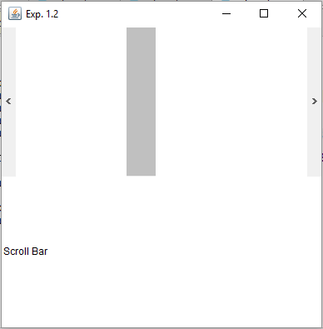

**package** exp2;  
  
**import** java.awt.*;  
**public class** Exp2_1 **extends** Frame {  
  
 **public static void** main(String[] args) {  
  
 Frame frame = **new** Frame();  
 frame.setTitle(**"Exp. 2.1"**);  
 frame.setSize(400,400);  
 frame.setVisible(**true**);  
 frame.setLayout(**new** GridLayout(2,3));  
  
 Button b1 = **new** Button(**"1"**);  
 frame.add(b1);  
  
 Button b2 = **new** Button(**"2"**);  
 frame.add(b2);  
  
 Button b3 = **new** Button(**"3"**);  
 frame.add(b3);  
  
 Button b4 = **new** Button(**"4"**);  
 frame.add(b4);  
  
 Button b5 = **new** Button(**"5"**);  
 frame.add(b5);  
  
 Button b6 = **new** Button(**"6"**);  
 frame.add(b6);  
  
 }  
}

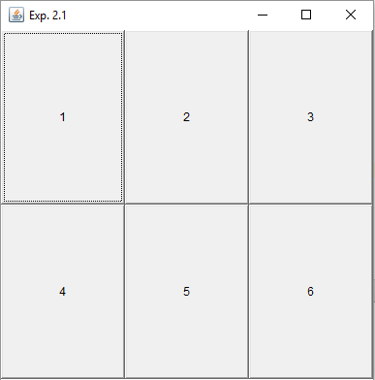

**package** exp2;  
  
**import** java.applet.Applet;  
**import** java.awt.*;  
**import** java.nio.Buffer; *//<applet code = Exp2_2 height = 400 width = 400> //</applet>***public class** Exp2_2 **extends** Applet {  
  
 **public void** init() {  
  
 setLayout(**new** FlowLayout(FlowLayout.***RIGHT***));  
  
 Button ok = **new** Button(**"Ok"**);  
 add(ok);  
  
 Button can = **new** Button(**"Cancel"**);  
 add(can);  
  
 Button exi = **new** Button(**"Exit"**);  
 add(exi);  
 }  
}

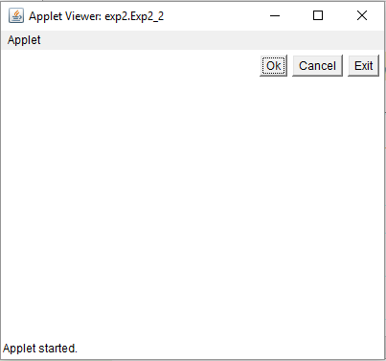

**package** exp3;  
  
**import** java.awt.*;  
**public class** Exp3_1 **extends** Frame {  
  
 **public static void** main(String[] args) {  
  
 Frame frame = **new** Frame();  
 frame.setTitle(**"Exp. 3.1"**);  
 frame.setSize(400,400);  
 frame.setVisible(**true**);  
  
 MenuBar mb = **new** MenuBar();  
 frame.setMenuBar(mb);  
  
 Menu menu = **new** Menu(**"Menu"**);  
 mb.add(menu);  
  
 CheckboxMenuItem pic = **new** CheckboxMenuItem(**"Picture"**,**true**);  
 menu.add(pic);  
  
 Menu home = **new** Menu(**"Home"**);  
 mb.add(home);  
  
 MenuItem paste = **new** MenuItem(**"Paste"**);  
 home.add(paste);  
  
 }  
}

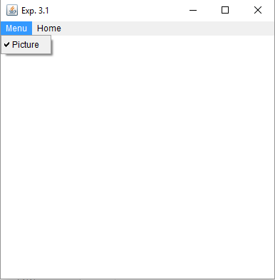

**package** exp3;  
  
**import** java.awt.*;

**public class** Exp3_2 **extends** Frame {  
  
 **public static void** main(String[] args) {  
  
 Frame frame = **new** Frame();  
 frame.setTitle(**"Exp. 3.2"**);  
 frame.setSize(400,400);  
 frame.setVisible(**true**);  
  
 MenuBar mb = **new** MenuBar();  
 frame.setMenuBar(mb);  
  
 Menu pageLayout = **new** Menu(**"PageLayout"**);  
 mb.add(pageLayout);  
  
 Menu referances = **new** Menu(**"Referances"**);  
 mb.add(referances);  
  
 Menu mailing = **new** Menu(**"Mailing"**);  
 mailing.setEnabled(**false**);  
 mb.add(mailing);  
  
 }  
}

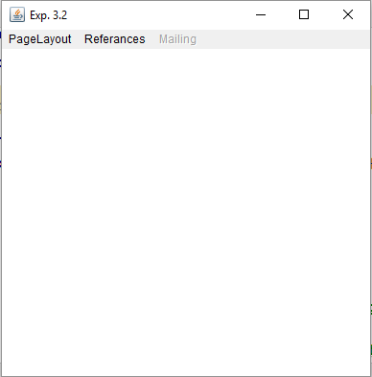

**package** exp4;  
  
**import** exp1.Exp1_1;  
  
**import** javax.swing.*;  
**import** java.awt.*;  
**import** java.awt.event.*;  
**public class** Exp4_1 **extends** JFrame {  
  
  
 Exp4_1() {  
  
 setTitle(**"Changing Color"**);  
 setSize(400,400);  
 setLayout(**new** FlowLayout());  
 setVisible(**true**);  
 setDefaultCloseOperation(JFrame.***EXIT_ON_CLOSE***);  
  
 String[] colors = {**"Red"**, **"Green"**, **"Blue"**};  
  
 JComboBox cb = **new** JComboBox(colors);  
 cb.addItemListener(**new** ItemListener() {  
 @Override  
 **public void** itemStateChanged(ItemEvent e) {  
 **switch** (cb.getSelectedIndex()) {  
 **case** 0: getContentPane().setBackground(Color.***RED***);  
 **break**;  
 **case** 1: getContentPane().setBackground(Color.***GREEN***);  
 **break**;  
 **case** 2: getContentPane().setBackground(Color.***BLUE***);  
 **break**;  
 }  
 }  
 });  
 add(cb);  
 }  
  
 **public static void** main(String[] args) {  
  
 Exp4_1 frame = **new** Exp4_1();  
  
 }  
}

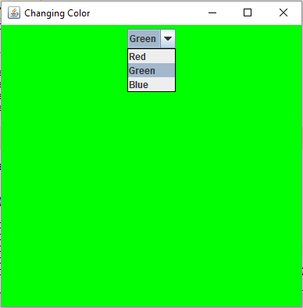

**package** exp4;  
  
**import** javax.swing.*;  
**import** java.awt.*;  
**public class** Exp4_2 **extends** JFrame {  
  
 Exp4_2() {  
  
 setTitle(**"Login Page"**);  
 setSize(400,150);  
 setLayout(**new** FlowLayout());  
 setVisible(**true**);  
 setResizable(**true**);  
 setLayout(**new** GridLayout(3,2));  
 setDefaultCloseOperation(JFrame.***EXIT_ON_CLOSE***);  
  
 JLabel id = **new** JLabel(**"Login ID"**);  
 add(id);  
  
 JTextField idt = **new** JTextField();  
 add(idt);  
  
 JLabel pss = **new** JLabel(**"Password"**);  
 add(pss);  
  
 JPasswordField pst = **new** JPasswordField();  
 add(pst);  
  
 JButton login = **new** JButton(**"Login"**);  
 add(login);  
  
 JButton cancel = **new** JButton(**"Cancel"**);  
 add(cancel);  
 }  
  
 **public static void** main(String[] args) {  
  
 Exp4_2 frame = **new** Exp4_2();  
 }  
}

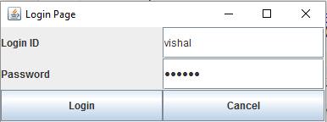

**package** exp5;  
  
**import** javax.swing.*;  
**import** java.awt.*;  
**import** java.awt.event.ActionEvent;  
**import** java.awt.event.ActionListener;  
**import** java.util.Random;  
**public class** Exp5_1 **extends** JApplet {  
  
  
 **public void** init() {  
  
 Container con = getContentPane();  
 con.setLayout(**new** FlowLayout());  
  
 JButton b = **new** JButton(**"Change Color"**);  
 b.addActionListener(**new** ActionListener() {  
 @Override  
 **public void** actionPerformed(ActionEvent e) {  
 **switch** (**new** Random().nextInt(3)) {  
 **case** 0:  
 con.setBackground(Color.***RED***);  
 **break**;  
 **case** 1:  
 con.setBackground(Color.***GREEN***);  
 **break**;  
 **case** 2:  
 con.setBackground(Color.***BLUE***);  
 **break**;  
 }  
 }  
 });  
 con.add(b);  
 }  
}

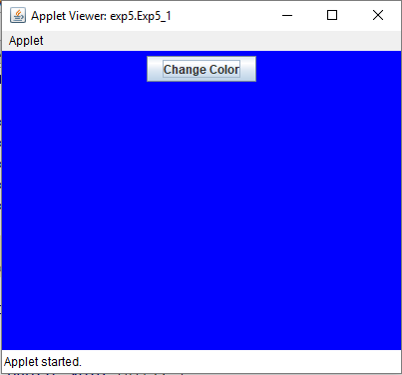

**package** exp5;  
  
**import** javax.swing.*;  
**import** javax.swing.tree.DefaultMutableTreeNode;  
**public class** Exp5_2 **extends** JFrame {  
  
 Exp5_2() {  
  
 setTitle(**"Exp. 5.1"**);  
 setSize(400,400);  
 setVisible(**true**);  
 setDefaultCloseOperation(JFrame.***EXIT_ON_CLOSE***);  
  
 DefaultMutableTreeNode root = **new** DefaultMutableTreeNode(**"Root"**);  
  
 DefaultMutableTreeNode veg = **new** DefaultMutableTreeNode(**"Vegetables"**);  
 root.add(veg);  
  
 DefaultMutableTreeNode v1 = **new** DefaultMutableTreeNode(**"Capsicum"**);  
 veg.add(v1);  
 DefaultMutableTreeNode v2 = **new** DefaultMutableTreeNode(**"Carrot"**);  
 veg.add(v2);  
 DefaultMutableTreeNode v3 = **new** DefaultMutableTreeNode(**"Tomato"**);  
 veg.add(v3);  
 DefaultMutableTreeNode v4 = **new** DefaultMutableTreeNode(**"Potato"**);  
 veg.add(v4);  
  
 DefaultMutableTreeNode fru = **new** DefaultMutableTreeNode(**"Fruits"**);  
 root.add(fru);  
  
 DefaultMutableTreeNode f1 = **new** DefaultMutableTreeNode(**"Banana"**);  
 fru.add(f1);  
 DefaultMutableTreeNode f2 = **new** DefaultMutableTreeNode(**"Mango"**);  
 fru.add(f2);  
 DefaultMutableTreeNode f3 = **new** DefaultMutableTreeNode(**"Apple"**);  
 fru.add(f3);  
 DefaultMutableTreeNode f4 = **new** DefaultMutableTreeNode(**"Blackberry"**);  
 fru.add(f4);  
  
 JTree tree = **new** JTree(root);  
  
 JScrollPane jsp = **new** JScrollPane(tree,ScrollPaneConstants.***VERTICAL_SCROLLBAR_ALWAYS***,ScrollPaneConstants.***HORIZONTAL_SCROLLBAR_AS_NEEDED***);  
 add(jsp);  
 }  
 **public static void** main(String[] args) {  
  
 Exp5_2 frame = **new** Exp5_2();  
 }  
}

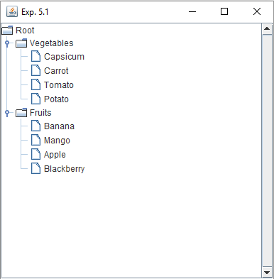

**package** exp6;  
  
**import** javax.swing.*;  
**import** java.awt.*;  
**import** java.awt.event.ActionEvent;  
**import** java.awt.event.ActionListener;  
**public class** Exp6_1 **extends** JApplet {  
  
 **public void** init() {  
  
 Container con = getContentPane();  
 con.setLayout(**new** FlowLayout());  
  
 JRadioButton r = **new** JRadioButton(**"RED"**);  
 r.addActionListener(**new** ActionListener() {  
 @Override  
 **public void** actionPerformed(ActionEvent e) {  
 **if**(r.isSelected()) {  
 con.setBackground(Color.***RED***);  
 }  
 }  
 });  
 con.add(r);  
  
 JRadioButton g = **new** JRadioButton(**"GREEN"**);  
 g.addActionListener(**new** ActionListener() {  
 @Override  
 **public void** actionPerformed(ActionEvent e) {  
 **if**(g.isSelected()) {  
 con.setBackground(Color.***GREEN***);  
 }  
 }  
 });  
 con.add(g);  
  
 JRadioButton b = **new** JRadioButton(**"BLUE"**);  
 b.addActionListener(**new** ActionListener() {  
 @Override  
 **public void** actionPerformed(ActionEvent e) {  
 **if**(b.isSelected()) {  
 con.setBackground(Color.***BLUE***);  
 }  
 }  
 });  
 con.add(b);  
  
 ButtonGroup bg = **new** ButtonGroup();  
 bg.add(r);  
 bg.add(g);  
 bg.add(b);  
  
 }  
}

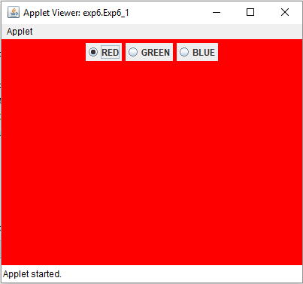

**package** exp7;  
  
**import** javax.swing.*;  
**import** java.awt.*;  
**import** java.awt.event.ActionEvent;  
**import** java.awt.event.ActionListener;  
**public class** Exp7_1 **extends** JApplet {  
  
 JTextField **ans**;  
  
 **public void** init() {  
  
 Container con = getContentPane();  
 con.setLayout(**new** GridLayout(2,2));  
  
 JTextField num1 = **new** JTextField();  
 con.add(num1);  
  
 JTextField num2 = **new** JTextField();  
 con.add(num2);  
  
 JButton but = **new** JButton(**"Largest"**);  
 but.addActionListener(**new** ActionListener() {  
 @Override  
 **public void** actionPerformed(ActionEvent e) {  
  
 **int** n1 = Integer.*parseInt*(num1.getText());  
 **int** n2 = Integer.*parseInt*(num2.getText());  
 **if**(n1 > n2) {  
 **ans**.setText(**"Larger number is. "** + num1.getText());  
 } **else** {  
 **ans**.setText(**"Larger number is. "** + num2.getText());  
 }  
 }  
 });  
 con.add(but);  
  
 **ans** = **new** JTextField();  
 **ans**.setEditable(**false**);  
 con.add(**ans**);  
 }  
}

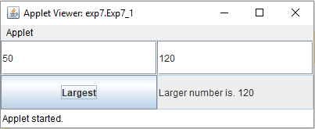

**package** exp7;  
  
**import** java.applet.Applet;  
**import** java.awt.*;  
**import** java.awt.event.MouseEvent;  
**import** java.awt.event.MouseMotionListener;  
**public class** Exp7_2 **extends** Applet {  
  
 **int x** = 0;  
 **int y** = 0;  
  
 **public void** init() {  
  
 addMouseMotionListener(**new** MouseMotionListener() {  
 @Override  
 **public void** mouseDragged(MouseEvent e) {  
  
 **x** = e.getX();  
 **y** = e.getY();  
 repaint();  
 }  
  
 @Override  
 **public void** mouseMoved(MouseEvent e) {  
  
 showStatus(**"X : "** + e.getX() + **" Y : "** + e.getY());  
 }  
 });  
 }  
  
 **public void** paint(Graphics g) {  
  
 g.setColor(Color.***RED***);  
 g.drawLine(0,0,**x**,**y**);  
 g.setColor(Color.***GREEN***);  
 g.drawLine(0,getHeight(),**x**,**y**);  
 g.setColor(Color.***BLUE***);  
 g.drawLine(getWidth(),0,**x**,**y**);  
 g.setColor(Color.***DARK_GRAY***);  
 g.drawLine(getWidth(),getHeight(),**x**,**y**);  
 g.setColor(Color.***CYAN***);  
 g.fillOval(**x**-25,**y**-25,50,50);  
 }  
}

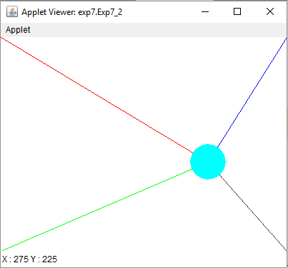

**package** exp8;

**import** javax.swing.*;  
**import** java.applet.Applet;  
**import** java.awt.*;  
**import** java.awt.event.ActionEvent;  
**import** java.awt.event.ActionListener;  
  
**public class** Exp8_1 **extends** Applet {  
  
 @Override  
 **public void** init() {  
  
 setLayout(**new** GridLayout(0,2));  
  
 JLabel num1 = **new** JLabel(**"Enter Number 1 "**);  
 add(num1);  
 JTextField numberInput1 = **new** JTextField();  
 numberInput1.setFont(**new** Font(**"Arial"**,Font.***PLAIN***,50));  
 add(numberInput1);  
  
 JLabel ans = **new** JLabel(**"Square of number is "**);  
 add(ans);  
 TextField ansOutput = **new** TextField();  
 ansOutput.setFont(**new** Font(**"Arial"**,Font.***PLAIN***,50));  
 ansOutput.setEditable(**false**);  
 add(ansOutput);  
  
 JButton addButton = **new** JButton(**"Square"**);  
 addButton.addActionListener(**new** ActionListener() {  
 @Override  
 **public void** actionPerformed(ActionEvent e) {  
 **int** num1 = Integer.*parseInt*(numberInput1.getText());  
 **int** ans = num1 * num1;  
 ansOutput.setText(Integer.*toString*(ans));  
 }  
 });  
 add(addButton);  
 }  
}

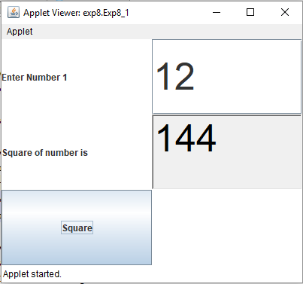

**package** exp8;  
  
**import** java.applet.Applet;  
**import** java.awt.*;  
**import** java.awt.event.AdjustmentEvent;  
**import** java.awt.event.AdjustmentListener;  
**public class** Exp8_2 **extends** Applet {  
  
 Scrollbar **s1**,**s2**,**s3**;  
 **int r** = 0,**b** = 0,**g** = 0;  
  
 @Override  
 **public void** init() {  
  
 setLayout(**new** BorderLayout());  
  
 setBackground(**new** Color(**r**,**b**,**g**));  
  
 **s1** = **new** Scrollbar(Scrollbar.***HORIZONTAL***,0,10,0,255);  
 **s1**.addAdjustmentListener(**new** AdjustmentListener() {  
 @Override  
 **public void** adjustmentValueChanged(AdjustmentEvent e) {  
 **r** = **s1**.getValue();  
 setBackground(**new** Color(**r**,**b**,**g**));  
 }  
 });  
 **s1**.setBackground(Color.***RED***);  
 add(**s1**,BorderLayout.***NORTH***);  
  
 **s2** = **new** Scrollbar(Scrollbar.***HORIZONTAL***,0,10,0,255);  
 **s2**.setBackground(Color.***GREEN***);  
 **s2**.addAdjustmentListener(**new** AdjustmentListener() {  
 @Override  
 **public void** adjustmentValueChanged(AdjustmentEvent e) {  
 **b** = **s2**.getValue();  
 setBackground(**new** Color(**r**,**b**,**g**));  
 }  
 });  
 add(**s2**,BorderLayout.***SOUTH***);  
  
 **s3** = **new** Scrollbar(Scrollbar.***VERTICAL***,0,10,0,255);  
 **s3**.setBackground(Color.***BLUE***);  
 **s3**.addAdjustmentListener(**new** AdjustmentListener() {  
 @Override  
 **public void** adjustmentValueChanged(AdjustmentEvent e) {  
 **g** = **s3**.getValue();  
 setBackground(**new** Color(**r**,**b**,**g**));  
 }  
 });  
 add(**s3**,BorderLayout.***EAST***);  
 }  
}

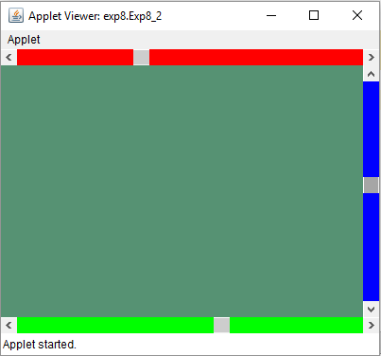

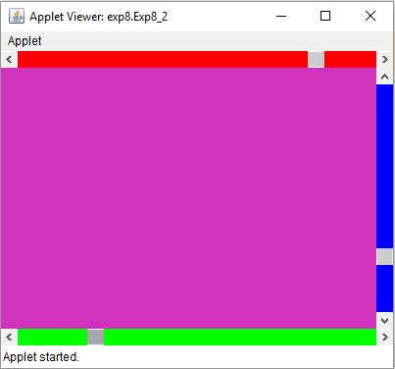

**package** exp9;  
  
**import** javax.swing.*;  
**import** java.awt.*;  
**import** java.awt.event.MouseEvent;  
**import** java.awt.event.MouseMotionAdapter;  
**public class** Exp9_1 **extends** JApplet {  
  
 **int x** = 0;  
 **int y** = 0;  
 String **point** = **""**;  
  
 @Override  
 **public void** init() {  
  
 addMouseMotionListener(**new** MouseMotionAdapter() {  
 @Override  
 **public void** mouseMoved(MouseEvent e) {  
  
 **x** = e.getX();  
 **y** = e.getY();  
 **point** = **"X : "** + e.getX() + **", Y : "** + e.getY();  
 showStatus(**"Moving mouse at : "** + **point**);  
 repaint();  
 }  
 });  
 }  
  
 @Override  
 **public void** paint(Graphics g) {  
  
 g.setColor(Color.***WHITE***);  
 g.fillRect(0,0,getWidth(),getHeight());  
 g.setColor(Color.***black***);  
 g.drawLine(0,0,**x**,**y**);  
 g.setColor(Color.***black***);  
 g.drawLine(getWidth(),0,**x**,**y**);  
 g.setFont(**new** Font(**"Arial"**,Font.***PLAIN***,40));  
 g.drawString(**point**,getWidth()/2,getHeight()/2);  
  
 }  
}

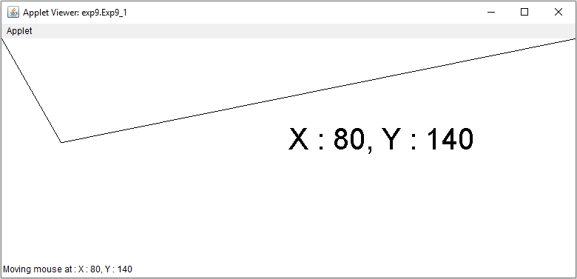

**package** exp10;  
  
**import** javax.swing.*;  
**import** java.awt.*;  
**import** java.net.InetAddress;  
**public class** Exp10 **extends** JFrame {  
  
 Exp10() {  
  
 setTitle(**"Exp 10"**);  
 setSize(320,240);  
 setVisible(**true**);  
 setDefaultCloseOperation(***EXIT_ON_CLOSE***);  
 setLayout(**new** FlowLayout());  
  
 **try** {  
  
 InetAddress add = InetAddress.*getLocalHost*();  
  
 JLabel ipAddressLable = **new** JLabel(**"Local Host Address : "** + add.getHostAddress());  
 add(ipAddressLable);  
  
 JLabel nameLabe = **new** JLabel(**"Local Host Name : "** + add.getHostName());  
 add(nameLabe);  
  
 } **catch** (Exception e) {  
 e.printStackTrace();  
 }  
 }  
  
 **public static void** main(String[] args) {  
  
 **new** Exp10();  
 }  
}

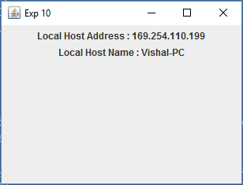

**package** exp11;  
  
**import** javax.swing.*;  
**import** java.awt.*;  
**import** java.awt.event.KeyAdapter;  
**import** java.awt.event.KeyEvent;  
**import** java.awt.event.KeyListener;  
**import** java.io.IOException;  
**public class** Exp11 **extends** JFrame {  
  
 **private** JEditorPane **htmlViewer**;  
  
 Exp11() {  
  
 setTitle(**"Exp 11"**);  
 setSize(630,480);  
 setVisible(**true**);  
 setDefaultCloseOperation(***EXIT_ON_CLOSE***);  
 setLayout(**new** BorderLayout());  
  
 **htmlViewer** = **new** JEditorPane();  
 **htmlViewer**.setEditable(**true**);  
 JScrollPane scrollPane = **new** JScrollPane(**htmlViewer**);  
 add(scrollPane,BorderLayout.***CENTER***);  
  
 JTextField urlText = **new** JTextField();  
 urlText.addKeyListener(**new** KeyAdapter() {  
 @Override  
 **public void** keyPressed(KeyEvent e) {  
 **if**(e.getKeyCode() == e.***VK_ENTER***) {  
 **try**{  
 **htmlViewer**.setPage(urlText.getText());  
 } **catch** (Exception ex) {  
 JOptionPane.*showMessageDialog*(**null**,ex.getMessage(),**"Error"**,JOptionPane.***ERROR_MESSAGE***);  
 }  
 }  
 }  
 });  
 add(urlText,BorderLayout.***SOUTH***);  
  
 }  
  
 **public static void** main(String[] args) **throws** Exception {  
  
 **new** Exp11();  
 }  
}

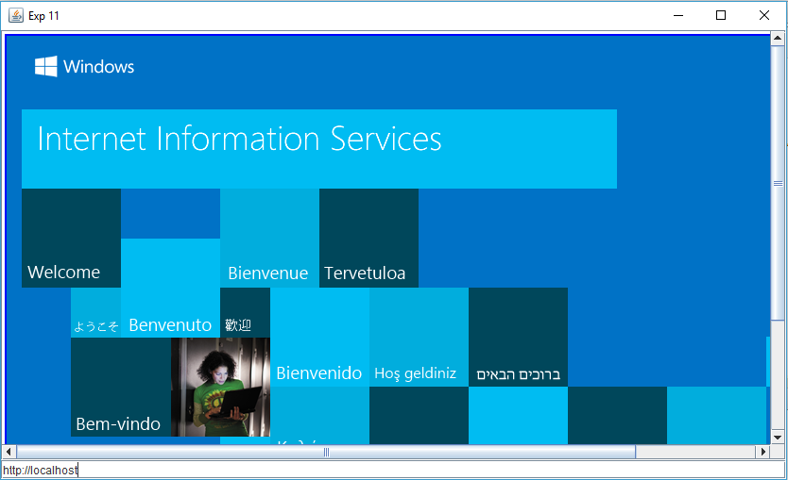

**package** exp12;  
  
**import** javax.swing.*;  
**import** java.awt.*;  
**import** java.net.URL;  
**public class** Exp12 **extends** JFrame {  
  
 Exp12(){  
  
 setTitle(**"Exp 11"**);  
 setSize(320,240);  
 setVisible(**true**);  
 setDefaultCloseOperation(***EXIT_ON_CLOSE***);  
 setLayout(**new** FlowLayout());  
 setLocationRelativeTo(**null**);  
  
 String url = JOptionPane.*showInputDialog*(**null**,**"Enter URL"**);  
 System.***out***.println(url);  
  
 **try** {  
  
 URL u = **new** URL(url);  
  
 JLabel protocol = **new** JLabel(**"Protocol : "** + u.getProtocol());  
 add(protocol);  
  
 JLabel port = **new** JLabel(**"Port : "** + u.getPort());  
 add(port);  
  
 JLabel host = **new** JLabel(**"Host : "** + u.getHost());  
 add(host);  
  
 JLabel file = **new** JLabel(**"File : "** + u.getFile());  
 add(file);  
  
 } **catch** (Exception e) {  
 e.printStackTrace();  
 }  
 }  
  
 **public static void** main(String[] args) {  
  
 **new** Exp12();  
 }  
}

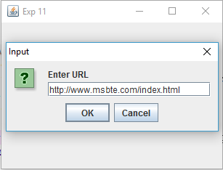

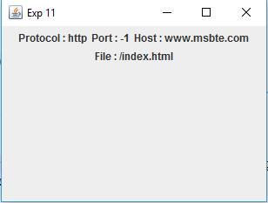

**package** exp13;  
  
**import** javax.swing.*;  
**import** java.awt.*;  
**import** java.sql.Connection;  
**import** java.sql.DriverManager;  
**import** java.sql.Statement;  
**public class** Exp13 **extends** JFrame {  
  
 **public static void** main(String[] args) **throws** Exception {  
  
 Class.*forName*(**"org.sqlite.JDBC"**);  
  
 Connection c = DriverManager.*getConnection*(**"jdbc:sqlite:Exp13.db"**);  
 System.***out***.println(**"Connection established.."**);  
  
 Statement s = c.createStatement();  
 s.execute(**"create table employee(emp_id INTEGER, emp_name STRING)"**);  
 System.***out***.println(**"Table created.."**);  
 }  
}

